**SET 6**

Network ID: **199.8.213.180**

Subnets Required: **3**

1. Answer the following questions for the parameters given above:
2. Subnet No(Which subnet the given IP address belongs to)
3. Subnet Mask
4. No of Usable Host in each subnet
5. No of address possible in the network
6. Network address
7. Broadcast address
8. Implement the application layer protocol FTP by assigning IP addresses mention in first question.

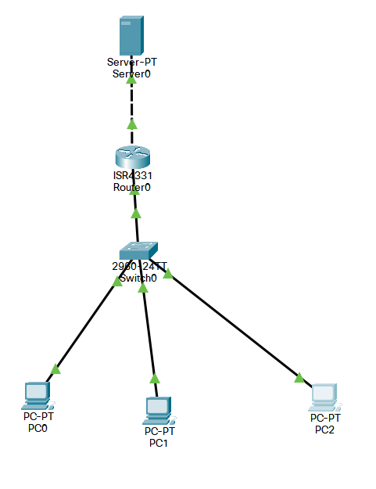

**Connect and put:**

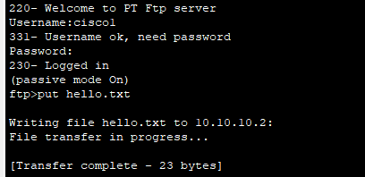

**Check:**

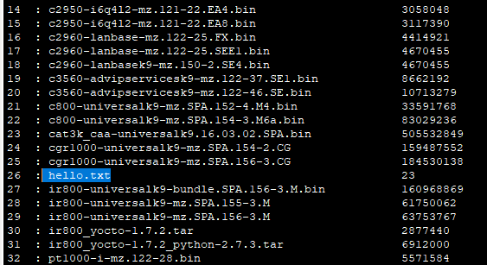

**Get :**

